**Mathematical Operations**

**Also known as “NO PAIN, NO GAIN”**



**NUMBERS and OPERATIONS**

**Grade Level: Fifth**

**Stephanie J. Olson**

solson@frontier.com

Bemidji State University

*Number Concepts for Elementary and Middle School Teachers*

Math 5064

Bemidji State University

Todd Frauenholtz | [tfrauenholtz@bemidjistate.edu](mailto:tfrauenholtz@bemidjistate.edu)

July 23, 2017

**Table of Contents**

Executive Summary……………………………………………………………………………………………4-6

**Section 1**: Addition…………………………………………………………………………………………….7-10

**Section 2:** Subtraction………………………………………………………………………………………..11-12

**Section 3:** Multiplication…………………………………………………………………………………….12-15

**Section 4:** Division………………………………………………………………………………………………16-17

**Section 5:** Step-by-Step……………………………………………………………………………………….17-21

**Section 6:** Fractions

Fraction Circles………………………………………………………………………………………..22-24

Mixed Fractions……………………………………………………………………………………….25-30

**Section 7:** Ratios………………………………………………………………………………………………….31-32

References…………………………………………………………………………………………………………..33

**Executive Summary**

The following unit was developed to meet the following Minnesota State Math Standard(s):

**Strand 5:** Numbers and Operations

**Standard:** Divide multi-digit numbers; solve real-world and mathematical problems using arithmetic.

**Numbers &**

**Benchmark:** 5.1.1.1

Divide multi-digit numbers, using efficient and generalizable procedures, based on knowledge of place value, including standard algorithms. Recognize that quotients can be represented in a variety of ways, including a whole number with a remainder, a fraction or mixed number, or a decimal.

5.1.1.2

Consider the context in which a problem is situated to select the most useful form of the quotient for the solution and use the context to interpret the quotient appropriately.

5.1.1.3

Estimate solutions to arithmetic problems in order to assess the reasonableness of results.

5.1.1.4

Solve real-world and mathematical problems requiring addition, subtraction, multiplication and division of multi-digit whole numbers. Use various strategies, including the inverse relationships between operations, the use of technology, and the context of the problem to assess the reasonableness of results.

5.1.2.4

Recognize and generate equivalent decimals, fractions, mixed numbers and improper fractions in various contexts.

5.1.3.1

Add and subtract decimals and fractions, using efficient and generalizable procedures, including standard algorithms.

6.1.2.1

Identify and use ratios to compare quantities; understand that comparing quantities using ratios is not the same as comparing quantities using subtraction.

**Strand 5:** Algebra

**Standard:** Understand and interpret equations and inequalities involving variables and whole numbers, and use them to represent and solve real-world and mathematical problems.

**Numbers &**

**Benchmarks**

5.2.3.2

Represent real-world situations using equations and inequalities involving variables. Create real-world situations corresponding to equations and inequalities.

The target audience is fifth grade students. Given the complexity of some of the concepts, there are sections of this unit that will require more than one class period of instruction and learning. The unit is designed to cover 15 math class periods.

In the first section of this unit, students be provided with a review of the *Properties of Addition* and place values. They will use blocks, chips, and sticks manipulatives to understand and solve problems. The second section will cover subtraction including the *Take Away Concept* and the *Comparison Concept* using colored blocks. Multiplication will be addressed in the third section and focus on the standard algorithm used for multiplication plus the “Easy Way” to solve multiplication problems. Supplemental multiplication learning will take place using math software games. Section 4, division, will include a review of the properties for division and using algorithms to solve real-world problems. Section 5 will demonstrate to students how important a step by step process is using real life examples. They will also be shown that many classroom activities have potential for mathematical thinking even though the main objective is not mathematical. In section 6, students will use “fraction circles” to develop skills in this area and use manipulatives to understand mixed fractions. The last section, 7, will introduce students to the understanding of ratios.

After completing this unit, students will be able to successfully answer questions for the Minnesota Comprehensive Assessment (MCA). Examples of these questions include:

**Place Value**

Enter the missing numbers.  
  
94,719 =

​ ten thousands  
​ thousands  
​ hundreds  
​ tens  
​ ones



**Division**

A football team has $53 to spend on hats for their fans. Each hat costs $11. How many hats can the team buy?

​ hats



**Mixed Numbers**

|  |  |  |  |  |
| --- | --- | --- | --- | --- |
| Write | |  | | --- | | 47 | | 9 | | as a mixed number in simplest form. |



**Ratio**

Minnesota Comprehensive Assessment (MCA)

**Mathematics Tests**

* Encourage students to use mathematics every day. They can practice by creating a grocery budget, explaining charts and graphs from newspaper and magazine articles, dividing food portions, using rulers to measure objects, measuring a recipe or adding prices on a shopping trip.
* Play games that involve numbers or computation.
* Encourage students to connect what they are learning in mathematics class to their hobbies, other classes and everyday life.

Once the unit is complete, a review of concepts will take place and students will share their learning with each other by showing how they have used the math concepts in their own life. A pre-assessment will be administered and based on these results; any concepts causing difficulty for the students will be reviewed and reassessed.

A **standard algorithm** is a step-by-step way to solve a problem. It is a process or set of rules to be followed in calculations or other problem-solving operations, especially by a computer.

A**lgorithm** is a word that refers to a process used to solve problems.

**Standard** means something that is normally used.

So, putting them together, **standard algorithm** means a normally used process to solve problems!

Students know how to add, subtract, multiply and divide. So now we will learn:

* Interpretations of various operations
* Connections between operations
* Non-standard algorithms
* An understanding of why standard algorithms work

**SECTION 1:** We will begin with **addition**.

Let’s recall The Properties of Addition.

Properties of Addition

For whole numbers a, b, or c hold the following addition properties:

* Associative Property: *(a + b) + c = a + (b + c)*
* Communitive Property: *a + b = b + a*
* Identity Property: 0 *+ a = a*
* Closure Property: *a + b* is another whole number
* Counting: *a + 1* is the whole number after *a*

Using the properties of addition sometimes we can see patterns in an operation by looking at the

operation table. We will use a BASE 10 ADDITION TABLE.

**EXERCISE 1**

Using your BASE 10 ADDITION TABLE give 2 examples of each of the properties.

1. Associative Property:

1.

2.

B. Communitive Property:

1.

2.

C. Identity Property:

1.

2.

D. Closure Property:

1.

2.

E. Counting

1.

2.

**EXERCISE 2:**

Looking at your ADDITION TABLE, list 4 patterns you can see.

1.

2.

3.

4.

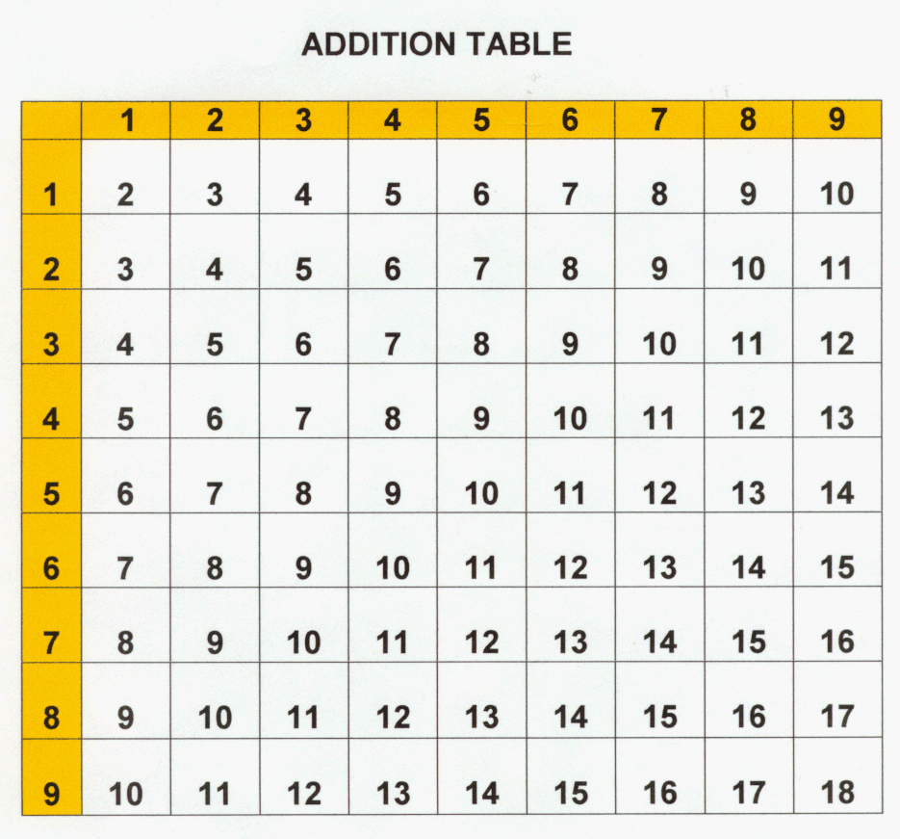

In the standard algorithm for addition, single digits are added in columns from right to left. When the sum of a column is greater than 9, the second (and possibly third) digits are carried over to the next column to be included in the next sum.

EXAMPLE 1.1: Use the standard addition algorithm to find the following sum.

1 1

6 2 3

+ 1 7 9

8 0 2

Starting in left column, add 3 + 9 = (12)

Put down your 2 then carry your 1 to the next column

Next column add 2 + 7 + 1 = (10)

Put down your 0 then carry 1 to the next column

Last column add 6 + 1 + 1 = (8)

**EXERCISE 3**

Using the above EXAMPLE 1.1 describe the standard addition algorithm to find the following sums.

5 9 2 1 3 4

+ 6 7 8 + 3 8 0

Remembering our place values show you use why algorithms work. Let’s look at the place values of EXAMPLE 1.1

6 2 3 = (6 $× 100)+\left(2 ×10\right)+(3 ×1)$

HUNDREDS TENS ONES

+ 1 7 9 = (1 $× 100)+\left(7 ×10\right)+$ (9 $×1)$

HUNDREDS TENS ONES

**EXERCISE 4**

Using your standard addition algorithm problems from **EXERCISE 3**, put them in their place values.

1. 5 9 2 B. 1 3 4

+ 6 7 8 + 3 8 0

**ACTIVITY: LEFT-TO RIGHT-ADDITION**

Students may find standard addition algorithm difficult to do mentally. Since we learn to read from left to right this manner of addition may seem more natural.

By switching the order, we begin with the largest values. This may make the addition a little more intuitive and easier to compute. Let’s look at **EXAMPLE 1.1.**

Blocks = 100 (hundreds) B Chips = 10 (tens) C Sticks = ones S

6 2 3 B B B B B B C C S S S

+ 1 7 9 B C C C C C C C S S S S S S S S S

7 9 12

7 10 2

8 0 2

Draw lines to represent the place values of the problem.

Beginning with the hundreds add all the blocks B

Then add all the chips C

Then add all the sticks S

There are 7 B or hundreds 9 C or tens 12 S or ones

We need to adjust our ones because 10 sticks = 1 chip. So, now we have another ten for a total of 10 and 2 ones.

We now need to adjust our tens because 10 chips = 1 block. So, now we have another hundred for a total of 8 and zero tens left.

Our answer, using the left-to-right addition algorithm is:

There are 8 B or hundreds 0 C or tens 2 S or ones

**EXERCISE 5**

Using the blocks, chips and sticks and the left-to-right addition algorithm, find the sum of:

5 9 2

+ 6 7 8

How many blocks, chips and sticks did you begin with?

How many blocks, chips and sticks do you have for the answer?

**SECTION 2:** Let’s look at **subtraction**.

The process of “taking away” or subtraction may be thought as the opposite of “putting together” or addition.

The **standard algorithm** that is currently taught for subtraction requires "regrouping," which has previously been called "borrowing." This **algorithm** is usually illustrated with manipulatives, in which 10 is exchanged for 10 ones and 100 is exchanged for 10 tens.

Here is the **TAKE AWAY CONCEPT** of standard subtraction algorithm using 2 different colored blocks.

**take away**

Using 2 different colored blocks I will show 13 – 6 = 7

Total 13

B B B B B B B B B B B B B B B B B B B B B B B B B B

6 orange 7 green

Using the **TAKE AWAY CONCEPT** **ACTIVITY** of standard subtraction algorithm we are “taking away” 6 and that leaves us with 7.

**EXERCISE 6**

Together with a partner and using the 2 colored blocks, demonstrate the **TAKE AWAY CONCEPT** of standard subtraction algorithm for:

16 – 11 = 5 12 – 8 = 4 14 – 3 = 11

Now let’s look at the **COMPARISON CONCEPT** **ACTIVITY** of standard subtraction algorithm for 13 – 6 = 7

We have a total of 13 blocks and need to subtract 6

B B B B B B B B B B B B B = total 13

B B B B B B = -6

Comparing the top row with the bottom row, we can see that 7 will be remaining in the top row.

**EXERCISE 7**

Together with a partner and using the 2 colored blocks, demonstrate the **COMPARISON CONCEPT** of standard subtraction algorithm for:

16 – 11 = 5 12 – 8 = 4 14 – 3 = 11

Discuss both concepts of standard subtraction algorithm with your partner. Which one do you prefer and why?

**EXERCISE 8**

Go back to your ADDITION TABLE.

Can we use this table for standard subtraction algorithm? Discuss with your partner

And support your answer with examples.

**EXERCISE 9**

Go back to your PROPERTIES OF ADDITION

Do the ASSOCIATIVE and COMMUNITIVE properties also work for subtraction?

Which one does? Which ones do not?

Support your answer(s) with an example:

**SECTION 3:**

A **multiplication algorithm** is an **algorithm** to multiply two numbers. Depending on the size of the numbers, different **algorithms** are in use. Efficient **multiplication algorithms** have existed since the advent of the decimal system.

The **standard algorithm** of multiplication is based on the principle that you already know: multiplying in parts—ones and tens separately then add.

Let’s recall the Properties of Multiplication.

Properties of Multiplication

For whole numbers a, b, or c hold the following multiplication properties:

* Associative Property: *(a $×$ b) $×$ c = a $×$ (b $×$ c)*
* Communitive Property: *a $×$ b = b $×$ a*
* Identity Property: 1 $×$ *a = a $× 1$*
* Closure Property: *a $×$ b* is another whole number
* Distributive Property: *a × (b + c)  =  a × b  +  a × c*

**EXERCISE 10**

Do you see a different property than what we had for addition?

Which is it?

Using your MULTIPLICATION TABLE give 2 examples of each of the properties.

1. Associative Property:

1.

2.

B. Communitive Property:

1.

2.

C. Identity Property:

1.

2.

D. Closure Property:

1.

2.

E. Distributive Property (make up 2 examples)

1.

2.

Can we give an example of the Distributive Property using only the MULTIPLICATION TABLE?

What if we were to use the MULTIPLICATION TABLE **AND** the ADDITION TABLE?

**EXERCISE 11:**

Looking at your MULTIPLICATION TABLE, list 4 patterns you can see.

1.

2.

3.

4.

**12× Multiplication Table**

|  |  |  |  |  |  |  |  |  |  |  |  |  |
| --- | --- | --- | --- | --- | --- | --- | --- | --- | --- | --- | --- | --- |
| **×** | **1** | **2** | **3** | **4** | **5** | **6** | **7** | **8** | **9** | **10** | **11** | **12** |
| **1** | 1 | 2 | 3 | 4 | 5 | 6 | 7 | 8 | 9 | 10 | 11 | 12 |
| **2** | 2 | 4 | 6 | 8 | 10 | 12 | 14 | 16 | 18 | 20 | 22 | 24 |
| **3** | 3 | 6 | 9 | 12 | 15 | 18 | 21 | 24 | 27 | 30 | 33 | 36 |
| **4** | 4 | 8 | 12 | 16 | 20 | 24 | 28 | 32 | 36 | 40 | 44 | 48 |
| **5** | 5 | 10 | 15 | 20 | 25 | 30 | 35 | 40 | 45 | 50 | 55 | 60 |
| **6** | 6 | 12 | 18 | 24 | 30 | 36 | 42 | 48 | 54 | 60 | 66 | 72 |
| **7** | 7 | 14 | 21 | 28 | 35 | 42 | 49 | 56 | 63 | 70 | 77 | 84 |
| **8** | 8 | 16 | 24 | 32 | 40 | 48 | 56 | 64 | 72 | 80 | 88 | 96 |
| **9** | 9 | 18 | 27 | 36 | 45 | 54 | 63 | 72 | 81 | 90 | 99 | 108 |
| **10** | 10 | 20 | 30 | 40 | 50 | 60 | 70 | 80 | 90 | 100 | 110 | 120 |
| **11** | 11 | 22 | 33 | 44 | 55 | 66 | 77 | 88 | 99 | 110 | 121 | 132 |
| **12** | 12 | 24 | 36 | 48 | 60 | 72 | 84 | 96 | 108 | 120 | 132 | 144 |

In my research of algorithms, I came across the **Partial Products Algorithms**. I found it interesting enough to add to my project. It is made more for 4th graders. I liked the concept and thought if you a 5th grader who was struggling with multiplication, this just may be the answer.

**ACTIVITY**

**The Easy Way to Multiply**

This lesson explains the **partial products algorithm** for multiplying two or three-digit numbers in columns that can be easier for some students than the [standard algorithm of multiplication](http://www.homeschoolmath.net/teaching/md/multiplication_algorithm.php" \t "_blank). The standard algorithm of multiplication is based on the principle that we already know: **multiplying in parts** (simply multiply ones and tens separately then add. However, in the standard way the *adding* is done at the same time as multiplying. In the ‘easy way” we multiply in parts and the adding is done separately.

|  |  |  |
| --- | --- | --- |
| **The standard algorithm way to multiply** | | **"The easy way"** |
| |  |  |  |  | | --- | --- | --- | --- | | |  | | --- | | 1       6**3** **×**  **4** http://www.homeschoolmath.net/teaching/md/images/eq-gray.gif **2** | | |  | | --- | | 1       **6** 3 **×**   **4** http://www.homeschoolmath.net/teaching/md/images/eq-gray.gif **2  5** 2 | | | |  | | --- | | Multiply the ones: 4 × 3 = 12  Place 2 in the ones place, but write the tens digit (1) above the tens column as a little memory note. You are *regrouping*  (or carrying). | | |  | | --- | | Then multiply the tens, ***adding*** the 1 ten that regrouped.  4 × 6  +  1 = 25  Write 25 in front of the 2. **Note** that 25 tens means 250! | | | | |  | | --- | | 6  3 **×**    4 http://www.homeschoolmath.net/teaching/md/images/eq.gif 1  2 +  2  4  0http://www.homeschoolmath.net/teaching/md/images/eq.gif 2  5  2 |      |  | | --- | | In the "easy way," we multiply in parts and the adding is done separately. | |
| **The standard algorithm way to multiply** | **"The easy way"** |
| |  |  |  |  | | --- | --- | --- | --- | | |  | | --- | | 3       7**5** **×**  **7** http://www.homeschoolmath.net/teaching/md/images/eq-gray.gif **5** | | |  | | --- | | 3        **7** 5 **×**   **7** http://www.homeschoolmath.net/teaching/md/images/eq-gray.gif **5  2** 5 | | | |  | | --- | | Multiply the ones: 7 × 5 = 35 Regroup the 3 tens. | | |  | | --- | | Multiply & add the tens: 7 × 7  +  3 = 52 | | | |  | | --- | | 7  5 **×**    7 http://www.homeschoolmath.net/teaching/md/images/eq.gif 3  5 +  4  9  0http://www.homeschoolmath.net/teaching/md/images/eq.gif 5  2  5 |   Multiply in parts then add. |

|  |  |  |  |  |  |  |  |  |  |  |  |  |  |  |  |  |  |  |  |
| --- | --- | --- | --- | --- | --- | --- | --- | --- | --- | --- | --- | --- | --- | --- | --- | --- | --- | --- | --- |
| Multiplying a 3-digit number happens in exactly the same way.  You multiply in parts: first the ones, then the tens,  then the hundreds. Lastly, add.  Just don't forget that you are multiplying *whole tens* and  *whole hundreds*, not just  “plain” numbers. | |  |  |  |  |  |  |  | | --- | --- | --- | --- | --- | --- | --- | | ones  7 × 6 |  | tens 7 × 20 |  | hundreds 7 × 500 |  | Add | | |  | | --- | | 5  2**6** **×**  **7** http://www.homeschoolmath.net/teaching/md/images/eq.gif **4  2** | |  | |  | | --- | | 5**2** 6 **×** **7** http://www.homeschoolmath.net/teaching/md/images/eq.gif 4  2 **1  4  0** | |  | |  | | --- | | **5** 2  6 **×** **7** http://www.homeschoolmath.net/teaching/md/images/eq.gif 4  2 1  4  0 **3  5  0  0** | |  | |  | | --- | | 5  2  6 ×      7 http://www.homeschoolmath.net/teaching/md/images/eq.gif 4  2 1  4  0 +  3  5  0  0 http://www.homeschoolmath.net/teaching/md/images/eq.gif 3  6  8  2 | | |

**EXERCISE 12**

Work the three problems using the [standard algorithm of multiplication](http://www.homeschoolmath.net/teaching/md/multiplication_algorithm.php" \t "_blank) then work them the “Easy Way”.

Standard Way

8 3 6 8 8 132

$×$ 4 $×$ 7 $×$ 9

The Easy Way

8 3 6 8 8 132

$×$ 4 $×$ 7 $×$ 9

Was the “Easy Way” easy for you? Explain.

**ACTIVITY**

On a day when we have use of the computer lab, I will have students play this online standard multiplication game. Not only will they be practicing their multiplication skills but also, they will see how quickly they can engage their brains with hand and mind coordination. We will have contests and see who will become the Prince or Princess Frog.



**MultipliACTION**

<http://cemc2.math.uwaterloo.ca/mathfrog/english/kidz/mult5.shtml>

**SECTION 4:** Let’s divide something!

On any given day, you may need to **divide**. It could be to divide school stuff, candy or food between friends. Or we may need to divide up our time to do everything we want to do in a day. And how about money? In any case, if we are dividing, using the standard algorithm is probably the strategy that we will be using. Let’s do some review:

**EXERCISE 13**

Remember the properties of division algorithm? Working in pairs, refresh your memories by giving an example of each property. Use only the set of integers in your examples.

1. If *d* divides *a* and *a* divides *b*, then *d* divides *b*.

Example:

1. *d* divides *a* if and only if *d* divides *(-a).*

Example:

1. *d* divides *a* if and only if *(-d)* divides *a.*

Example:

1. +/-- 1 divides *a* for every integer *a.*

Example:

1. *d* divides 0 for every *d* not equal to 0.

Example:

1. If *d* divides *a* and **d** divides *b*, then d divides ***(a $± b$).***

Example:

1. If *d* divides *a* and *d* divides *b*, then *d* divides *(ax + by)* for any integer *x* and *y.*

Example:

1. If *a + b = t* and *d* divides any two of the three, then *d* divides the third.

Example:

Let’s practice! Complete the division sentences.

**EXERCISE 14**

**What $÷$ What = 12 ? 253 $÷$ What = What ? What $÷$ 9 = What ?**

**199 25 126 225 7**

**8 73 12 96 113 27**

**84 23 9 78 11**

**253**

**9**

$÷$**= 12 $÷$ = $÷$ =**

**33 35 192 191 32**

**66 28 182 641 2**

**59 177 4 222 69 3**

$÷$**= 91 =**

**7**

$÷$**= $÷$ = 6**

**SECTION 5: Step by Step…**

Many classroom activities have potential for mathematical thinking even though the main objective is not mathematical. We have discussed how standard algorithm is a step-by-step solution. Each step has clear instructions similar to a recipe.

So, let’s add some art with math!

**ACTIVITY**

Let's try doing this with a new and fun activity, like making **paper airplanes**!

In this activity, we will create a step by step algorithm to help each other fold a paper airplane.

**Directions:**

1. Cut out the steps for making a paper airplane.
2. Work together to choose the six correct steps from the nine total options.
3. Glue the six correct steps, in order, onto a separate piece of paper.
4. Trade the finished algorithm with another person or group and let them use it to make their plane!

How many of you were able to follow your classmates' algorithms to make your airplanes?

* + What would you have added to make the algorithm even better?
  + What if the algorithm had been only one step: "Fold a Paper Airplane"?
    - Would it have been easier or harder?
    - What if it were forty steps?
* What was your favorite part about that activity?

**Real-Life Algorithms**

Paper Airplane Worksheet

Unplugged

U

You can use algorithms to help describe things that people do every day. In this activity, we will create an algorithm to help each other make paper airplanes.

Cut out the steps of making an airplane below. Glue the six correct steps, in order, onto a separate piece of paper. Trade your finished algorithm with another person or group and let them use it to make an actual flying model paper plane!

|  |  |  |  |  |
| --- | --- | --- | --- | --- |
| **CUT CENTER OUT OF PAPER** | |  |  | | --- | --- | |  |  |   **CREASE PAPER DOWN THE CENTER** | **CRUMBLE PAPER** |
| **FOLD TOP CORNERS TO CENTER** | **RIP CORNER OFF PAPER** | **FOLD CORNER SIDES TO CENTER** |
| **TOSS FINISHED PLANE** | **FOLD PAPER IN HALF AGAIN** | **PULL SIDES DOWN** |

**ACTIVITY**

My students know I was a librarian for many years and I still love books! In fact, for their English class they are reading my favorite chapter book and 1995 Newbury winner, *WALK TWO MOONS* by Sharon Creech.

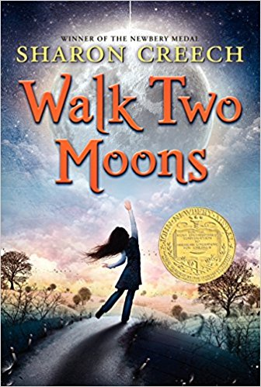

Some of the students stressed their concerns to me that they may not be able to finish the book in due time. Let’s do some English with math. I suggested to them “Let’s see if we can estimate how much time you will need for this reading assignment.”

I suggested 2 experiments: 1) How many words can they read a minute?

2) How long will it take them to read this chapter book?

I would set a timer and for five minutes while students read their book. When the five minutes are up, students will count the number of words on a **full page** they have read and record it. Then count the remainder of the words they read in that 5 minutes.

They now can figure out how many words they read a minute and estimate how long it will take them to complete the book.

Knowing the chapter book has 288 pages, and it is not a picture book, students can estimate how long it will take them to finish *Walk Two Moons*.

My results for the experiment are:

* 981 words in 5 minutes--**DIVISION**
* 228 words on one full page--**MULTIPLICATION**
* 288 pages total

Using the standard algorithm of division, I found how many words I read in one minute:

* **981** (words read in 5 minutes) $÷$**5** (minutes) = **196.2** words a minute

I then used the standard algorithm of multiplication to estimate how many words in the book.

We will use the full-page number of words 228 multiplied by the number of pages in the book:

* **228** (one full page of words) $×$**288** (number of pages of *Walk Two Moons* = Approximately **80,640** words.

Now I divide the estimated number of words in *Walk Too Moons* by my words per minutes:

* **80,640 $÷$ 228 = 353.68** minutes
* Divide minutes by one hour (60 minutes) **353.68 $÷$ 60 = 5.89**
* I estimate it will take me **5.89 hours**---almost 6 hours---to read Walk Two Moons.

Students:

1. Together we will count the number of words on a full page. A third of the class will count page 2; a third page 5 and the other third page 6. We will then average our finding and use this as our **FULL-PAGE** number.

AVERAGE NUMBER OF WORDS: \_\_\_\_\_\_\_\_\_\_\_\_\_\_\_

1. I will set a timer for 5 minutes and students will read until I say stop.
2. After 5 minutes, mark the spot where you ended and count all the words you read. NOTE: we already have numbers for pages 2, 5 and 6.

YOUR TOTAL NUMBER OF WORDS READ: \_\_\_\_\_\_\_\_\_\_\_\_\_\_\_\_\_\_\_\_\_\_\_\_\_\_\_\_\_

1. Take your **TOTAL WORDS** and divide that number by 5. Example: 981 $÷$ 5 = 196.2 This is your “words per minute” you read.

TOTAL WORDS: \_\_\_\_\_\_\_\_\_\_\_\_\_\_\_\_\_\_\_\_\_\_\_\_\_\_\_\_\_\_\_

1. We estimated that *Walk Two Moons* had approximately **80,640** words.
2. Now divide your “words per minute” number in the 80,640.

WORDS PER MINUTE: \_\_\_\_\_\_\_\_\_\_\_\_\_\_\_\_\_\_\_\_\_\_\_\_\_\_\_\_\_\_\_\_\_\_

1. Your answer can then be divided by 60 minutes.

WORDS DIVIDED BY 60: \_\_\_\_\_\_\_\_\_\_\_\_\_\_\_\_\_\_\_\_\_\_\_\_\_\_

1. How long will it take you to read *Walk Two Moons* ?

**ACTIVITY**

**Planting Pumpkins**

Mrs. Sjerven’s science department is doing an experiment with pumpkin plants. She has asked us to plant 12 pumpkin plants so they will be sprouting for spring planting.

Mrs. Sjerven will provide: containers, potting soil and seeds. Let's mix some science with math and help her class out!

In this activity, similar to the paper airplanes, we will create a step by step algorithm to plant pumpkin seeds.

1. Cut out the squares on your worksheet.
2. Work together to choose the six correct steps from the nine total options.
3. Glue the six correct steps, in order, onto a separate piece of paper.
4. Trade the finished algorithm with another person or group and let them use it to plant their pumpkin seed!

Did each group do the same STEP BY STEP process for planting their seeds?

Any group do something different?

Was it important to use a STEP BY STEP process in planting your seeds?

Was it suggested to any group to hug an elephant?

**Real-Life Algorithms**

Plant a Seed Worksheet

Unplugged

U

You can use algorithms to help describe things that people do every day. In this activity, we will create an algorithm to help each other plant a seed.

Cut out the steps of planting a seed below, then work together to glue the six the correct steps, in order, onto a separate piece of paper. Trade your finished algorithm with another person or group and let them use it to plant their seed!

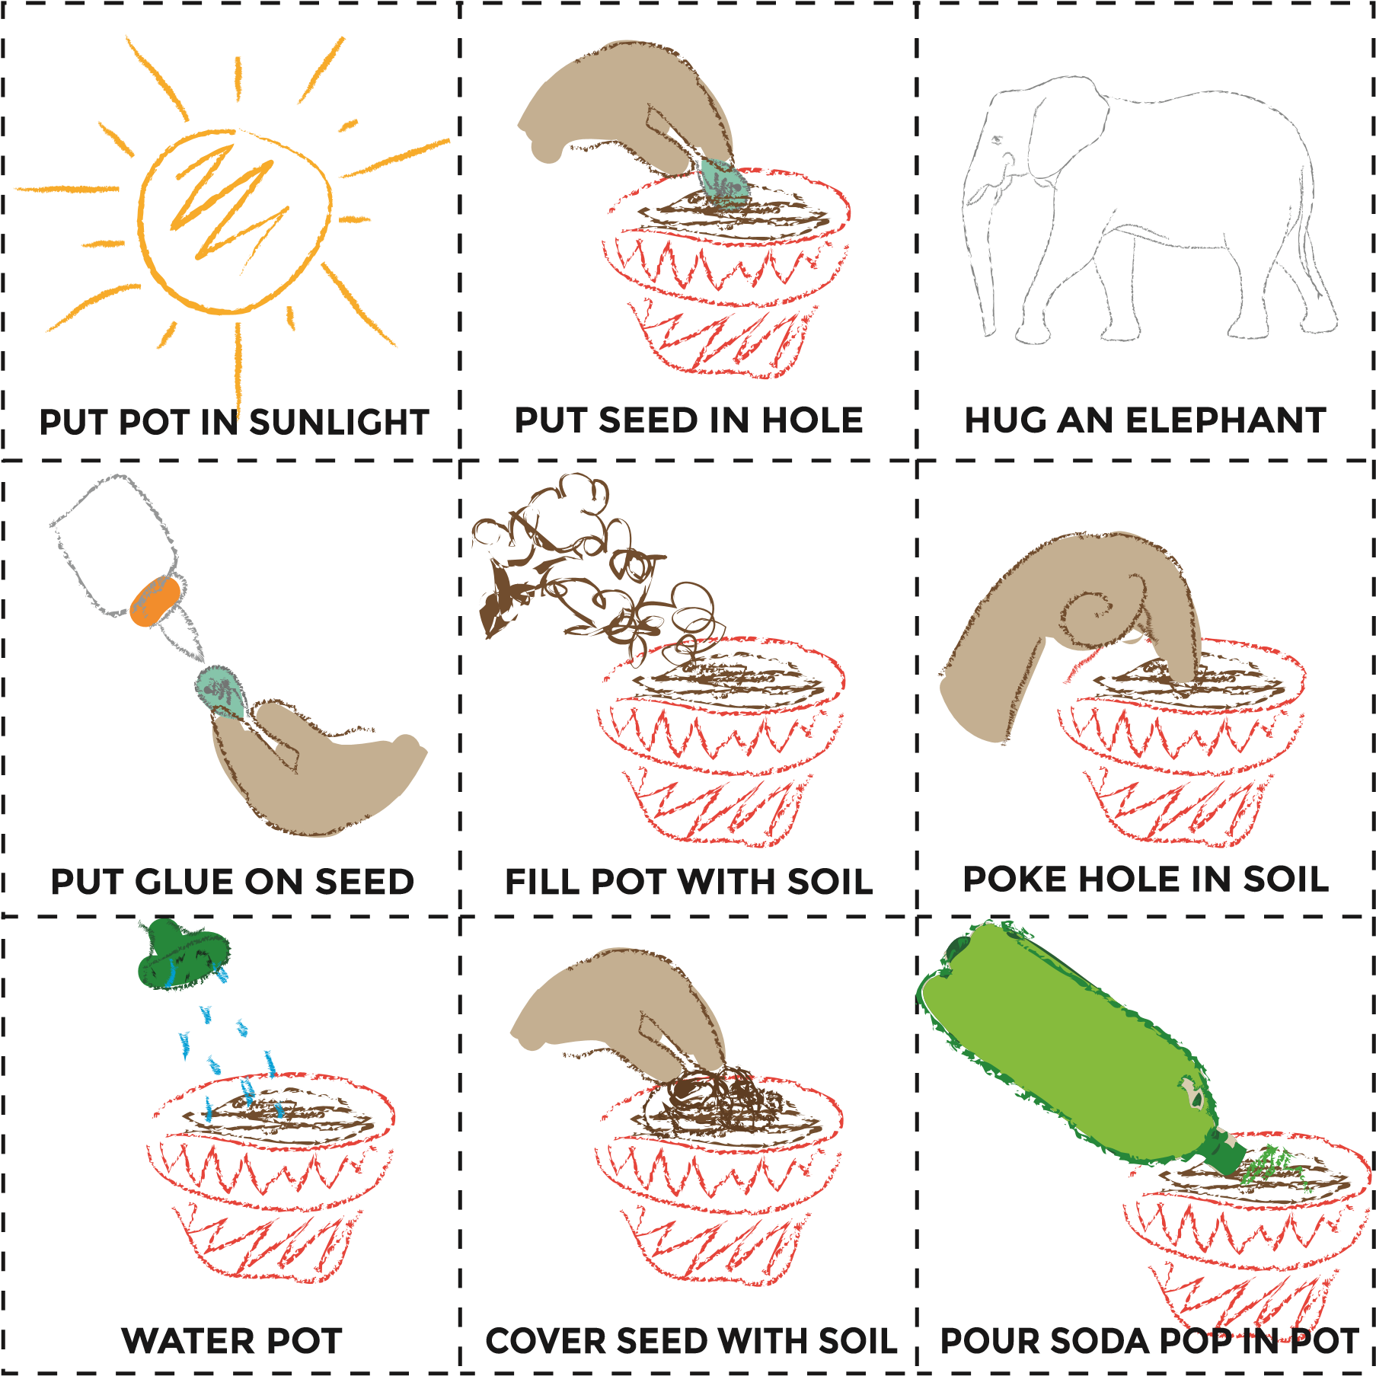

**Section 6: FRACTION CIRCLES**

Notice in our *Walk Two Moons* activity, we divided the classroom into “thirds”? Let’s review our fraction circles.

Fraction circles are a set of nine circles of various colors. Each circle is broken into equal fractional parts and uses the same-sized whole or unit. The circles include one unit as well as circles divided into halves, thirds, quarters, fifths, sixths, eighths, tenths, and twelfths. For this exercise, we will use a unit and fractional parts to an eighth.

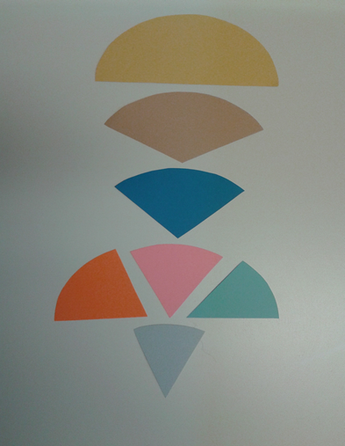

1

BLACK

2

YELLOW

3

BROWN

4

BLUE

5

ORANGE

6

PINK

7

LIGHT BLUE

8

GRAY

* 1. BLACK == a whole or unit.
  2. YELLOW == 1 unit.
  3. BROWN == 1 unit.
  4. BLUE == 1 unit.
  5. ORANGE == 1unit.
  6. PINK == 1 unit.
  7. LIGHT BLUE == 1 unit.
  8. GRAY == 1 unit.

**ACTIVITY**

1. Using your fraction circles, how would you show a “third” of the class?
2. 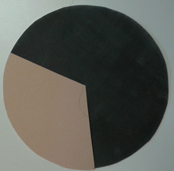 B. 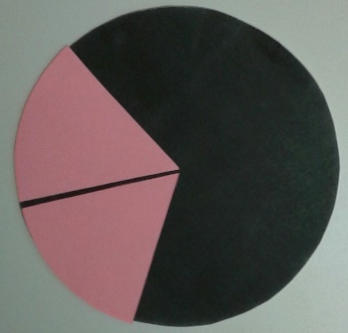
3. If one brown fraction piece equals a third of the class, what does two pink equal?
4. If two pink equal a third of the class, what would one pink equal?
5. If you wanted to show two thirds of the class, what would you add to picture **A**?
6. What would you add to picture **B** to show two thirds of the class?

C. 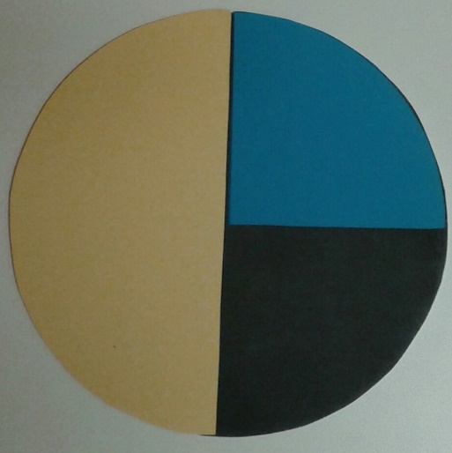 D. 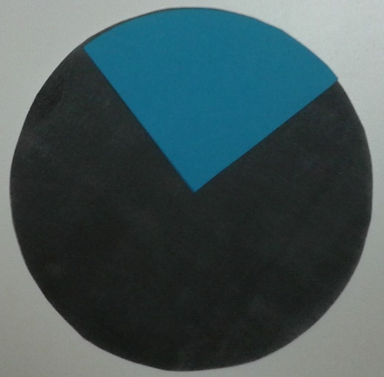

1. Look at picture **C**. I was so hungry after school I ate a quarter of the pie. But my brother ate half! How much pie is left for our parents?
2. If our mom and dad share the remainder of the pie, how big of a piece would each of them get?
3. If two gray fraction pieces make up a fourth of a pie, how many gray would it take to make a whole pie? A half of a pie?

**EXERCISE 14**

Using colored pencils and the colors of your fractional parts, color in the worksheet. Color only the fraction amounts stated.

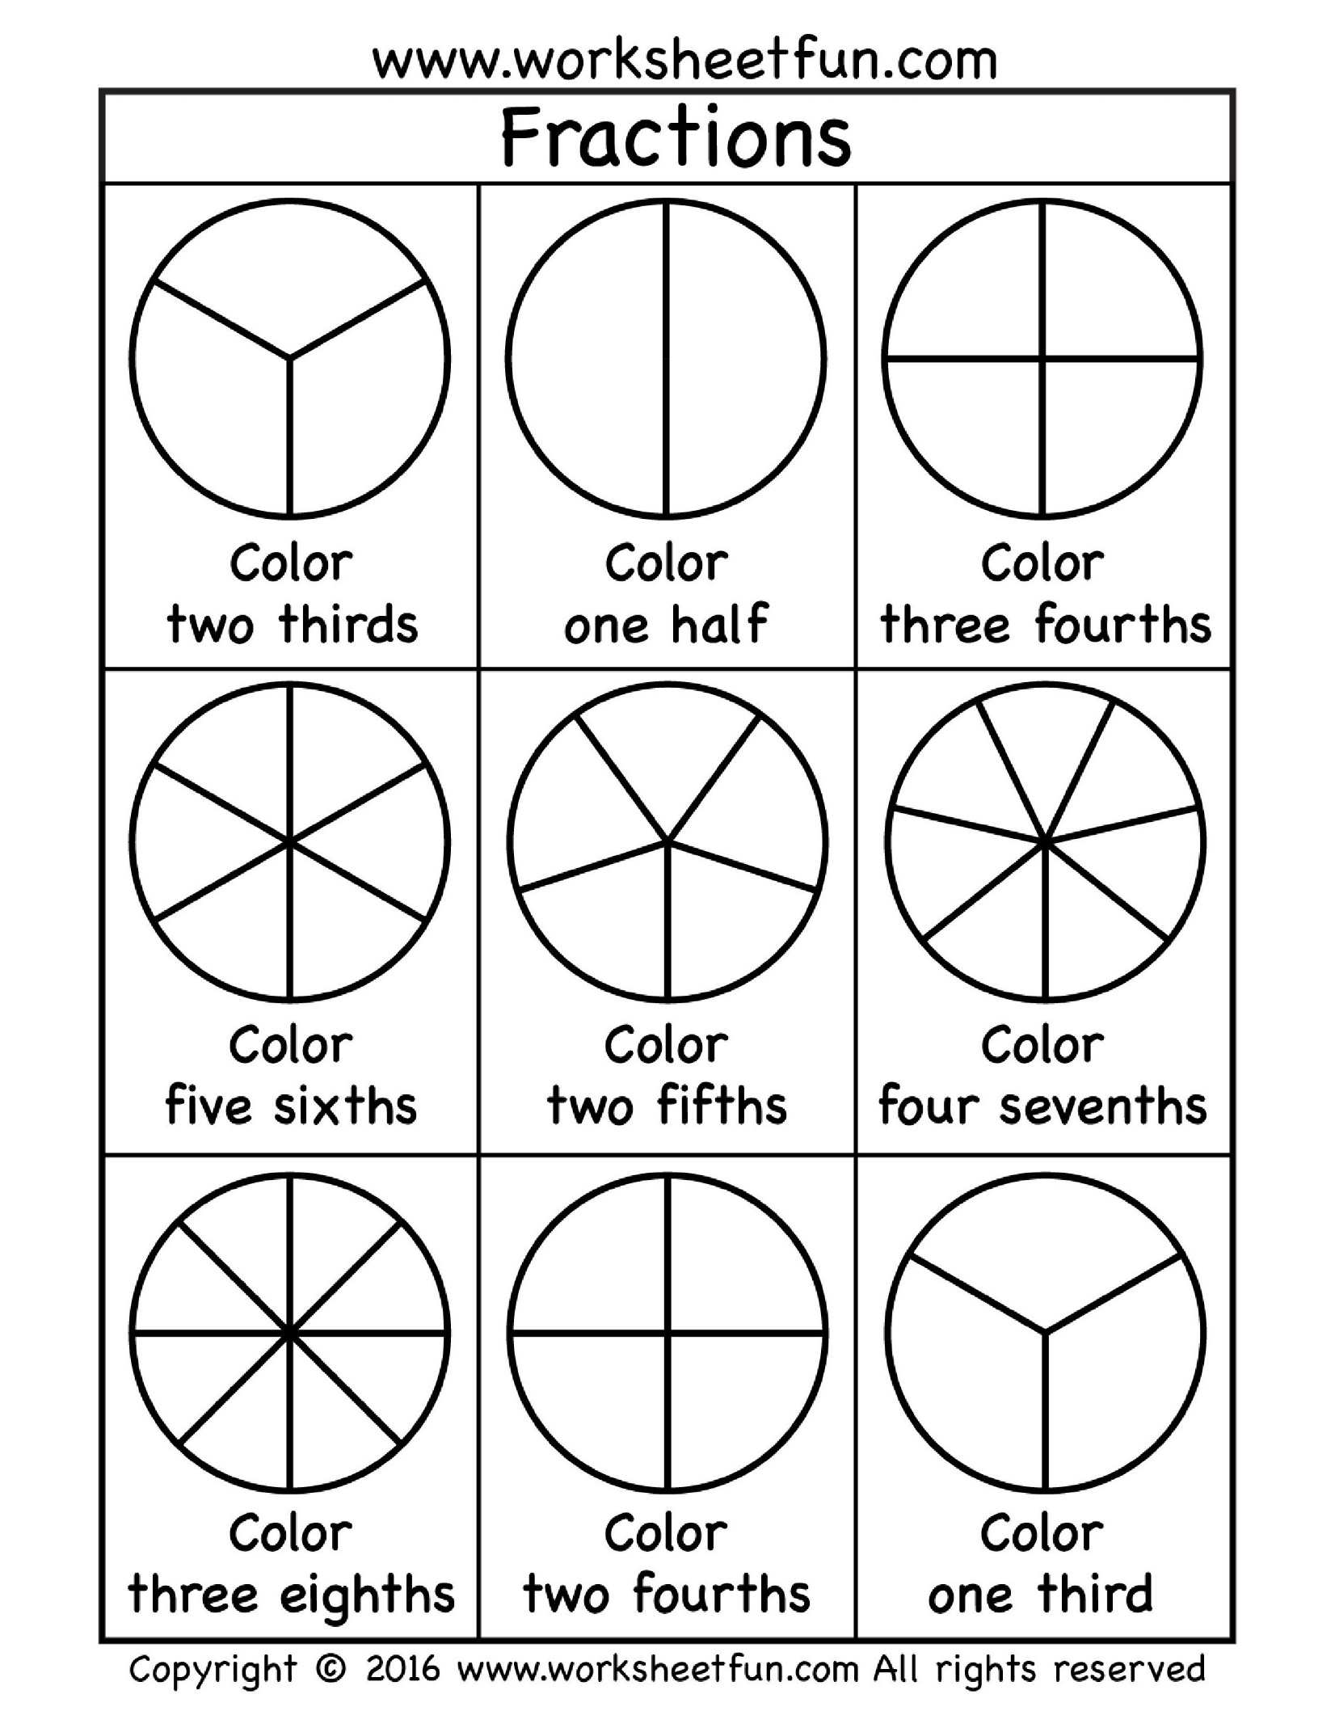

**There are three types of fraction:**

$$\frac{3}{5} \frac{9}{5} 2\frac{1}{3}$$

**Proper fraction Improper fraction Mixed fraction**

**Whole number**

**Numerator**

2 $\frac{1}{3}$

**Denominator**

**Explaining Multiplication Algorithms with Fractions**

The algorithm for multiplying fractions can be closely tied to reasoning with pictures of fraction multiplication. For example, suppose we wanted to show the following:

**1 $\frac{3}{8}$ × 3 =**

A picture speaks a thousand words. Better yet…a PIZZA picture 😊

**Multiplying Mixed Fractions**

**To multiply** [**Mixed Fractions**](http://www.mathsisfun.com/mixed-fractions.html)**:**

1. Convert to [**Improper Fractions**](http://www.mathsisfun.com/improper-fractions.html)
2. [Multiply the Fractions](http://www.mathsisfun.com/fractions_multiplication.html)
3. Convert the result back to **Mixed Fractions**

**Example: What is 1 $\frac{3}{8}$ × 3?**

Think of Pizzas!

|  |  |
| --- | --- |
| pie fullpie 3/8 | is 1 pizza and 3 eighths of another pizza. |

First, convert the mixed fraction (1 $\frac{3}{8}$) to an improper fraction ():

|  |  |
| --- | --- |
| pie 8/8pie 3/8 | Cut the whole pizza into eighths and how many eighths do you have in total?  A whole pizza is 8 slices plus the 3 eighths of a part of another pizza = 8 + 3 = 11 eighths of pizza. |

We want enough for the whole class so let’s multiply by 3:

$$1\frac{3}{8} × 3 = \frac{11}{8} × \frac{3}{1} = \frac{33}{8}$$

Now we have 33 eighths!

|  |
| --- |
| pie 8/8pie 3/8 pie 8/8pie 3/8 pie 8/8pie 3/8 |

Now covert to a mixed fraction.

|  |  |
| --- | --- |
| pie 8/8pie 8/8 pie 8/8pie 8/8 pie 1/8 | 33 eighths are 4 whole pizzas (4 × 8 = 32) and 1 eighth left over. |

Let’s observe our work in one equation:

1 $\frac{3}{8}$ × 3 = $\frac{11}{8}$ × $\frac{3}{1}$ = $\frac{33}{8}$ = 4 $\frac{1 }{8}$

**EXERCISE 16**

In the five pictures below, circle the correct answer that pertains to the fraction circle question.

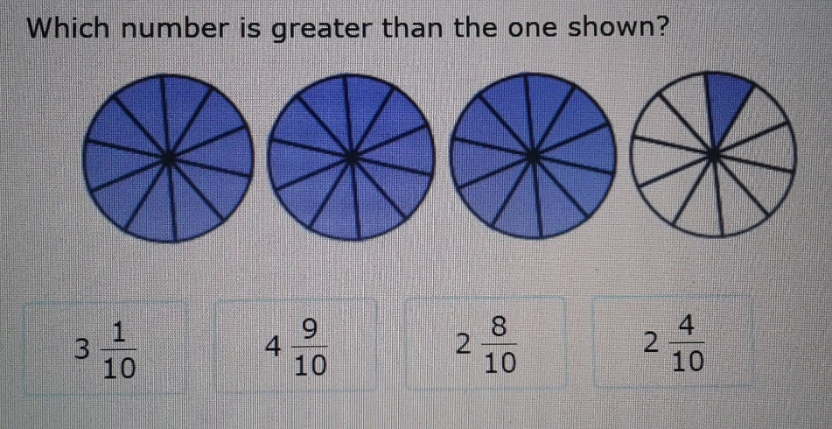

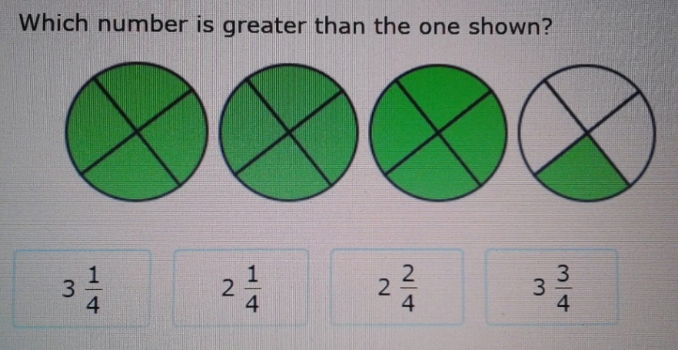

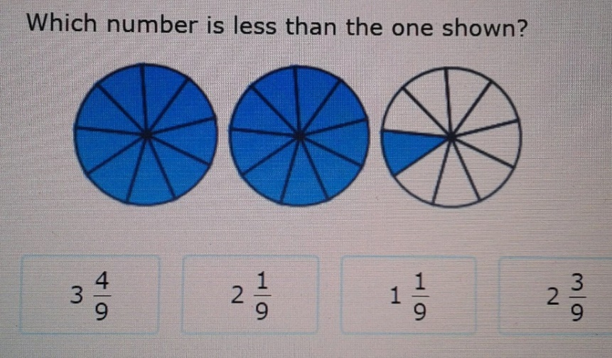

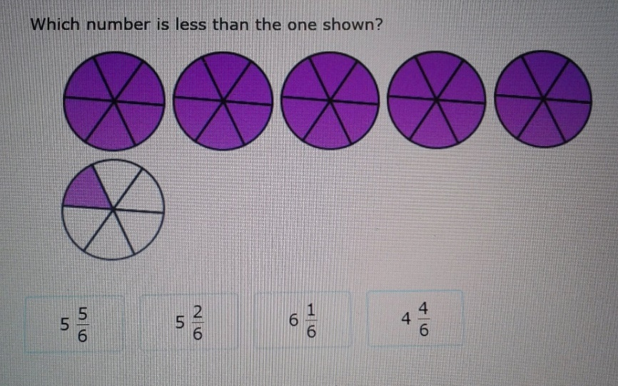

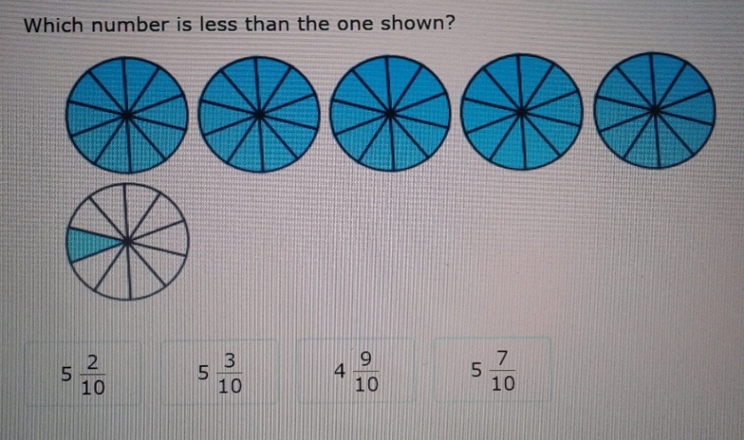

**ACTIVITY**

All this math has made us HUNGRYYYYYY! Remember how we said algorithms are a step by step process, similar to a recipe? Let’s make some cupcakes!

**Miss Olson’s Amazing Cupcakes**

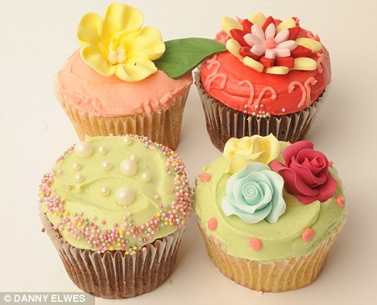

**Ingredients**

1. 1 1/2 cups flour
2. 1 1/2 teaspoons baking powder
3. 1/4 teaspoon salt
4. 2 large eggs
5. 2/3 cup sugar
6. 1 1/2 sticks (12 tablespoons) butter, melted
7. 2 teaspoons pure vanilla extract
8. 1/2 cup milk

**Directions**

STEP 1: Preheat oven to 375 degrees. Line muffin cups with papers.

STEP 2: Cream butter and sugar till light and fluffy.

STEP 3: Beat in eggs one at a time.

STEP 4: Add flour (mixed with baking powder and salt) alternating with milk beat well.

STEP 5: Stir in vanilla.

STEP 6: Divide evenly among pans and bake for 18 minutes. Let cool in pans.

Uh oh…We have a problem This recipe only makes 18 cupcakes!!! Our class is bigger than that!

Working together in groups of three DOUBLE the ingredient recipe to the cupcakes. Have someone in your group record the new recipe. If you have a fraction, make sure your answer is in mixed fraction form.

**Ingredients**

1. Flour \_\_\_\_\_\_\_\_\_\_\_\_\_\_\_\_\_

2. Baking powder \_\_\_\_\_\_\_\_\_\_\_\_\_\_\_\_\_

3. Salt \_\_\_\_\_\_\_\_\_\_\_\_\_\_\_\_\_

4. Eggs \_\_\_\_\_\_\_\_\_\_\_\_\_\_\_\_\_

5. Sugar \_\_\_\_\_\_\_\_\_\_\_\_\_\_\_\_\_

6. Butter \_\_\_\_\_\_\_\_\_\_\_\_\_\_\_\_\_

7. Vanilla \_\_\_\_\_\_\_\_\_\_\_\_\_\_\_\_\_

8. Milk \_\_\_\_\_\_\_\_\_\_\_\_\_\_\_\_\_

Algorithms are a **STEP BY STEP** process. And a recipe is a **STEP BY STEP** process.

1. If you work an algorithm problem out of “step”, what do you think will happen?
2. Look at the **Directions** to the cupcake recipe. Can we do STEP 6 before we do STEP 4? Why not?
3. Can we do STEP 5 before STEP 2? Explain.
4. If we double the ingredients to the cupcake recipe, do we also double the temperature of the oven?

Remember, it is important to do recipes and everyday functions in a step by step manner. Algorithms require the same process or the results will not be what you are looking for.

We want to thank Mrs. Sjerven’s class for allowing us to help with their pumpkin seed experiment. Perhaps we should also make enough cupcakes for her class.

In your groups, lets **TRIPLE** the cupcake recipe. Remember, you have a fraction, make sure your answer is in mixed fraction form.

**Ingredients**

1. Flour \_\_\_\_\_\_\_\_\_\_\_\_\_\_\_\_\_

2. Baking powder \_\_\_\_\_\_\_\_\_\_\_\_\_\_\_\_\_

3. Salt \_\_\_\_\_\_\_\_\_\_\_\_\_\_\_\_\_

4. Eggs \_\_\_\_\_\_\_\_\_\_\_\_\_\_\_\_\_

5. Sugar \_\_\_\_\_\_\_\_\_\_\_\_\_\_\_\_\_

6. Butter \_\_\_\_\_\_\_\_\_\_\_\_\_\_\_\_\_

7. Vanilla \_\_\_\_\_\_\_\_\_\_\_\_\_\_\_\_\_

8. Milk \_\_\_\_\_\_\_\_\_\_\_\_\_\_\_\_\_

**SECTION 7: Ratios**

Students have had several lessons with fractions and percentages. I would like to introduce them to ratios before they enter the 6th grade.

In mathematics, a **ratio** is a relationship between two **numbers** indicating how many times the first **number** contains the second.

**For example**: If a bowl of fruit contains eight oranges and six lemons, then the **ratio** of oranges to lemons is eight to six, written **8 : 6** which is equivalent to the **ratio 4:3.**

The corn is ready! But prices have increased in the last 20 years. Here are seven different ads from sellers of corn in the area 20 years ago.

What was the ratio of corn to cost for each ad?

**EXAMPLE 1**: We see in one ad that 9 fresh corn can be purchased for 99¢. We can write this as **9 : 99** which is the equivalent of **1 : 11.**

**EXAMPLE 2**: We see another ad has Golden sweet corn selling 3 for 39¢. We can write this as **3 : 39** which is the equivalent of **1 : 13.**

Using these two examples we see the one ads corn is **1 for 11¢** and the other ads corn is **1 for 13¢.**

1. What was the ratio of corn to cost for the other five ads?

Ad 1) \_\_\_\_\_\_\_\_\_\_\_\_ Ad 2) \_\_\_\_\_\_\_\_\_\_\_\_\_\_\_Ad 3) \_\_\_\_\_\_\_\_\_\_\_\_\_\_\_ Ad 4) \_\_\_\_\_\_\_\_\_\_\_\_\_\_ Ad 5) \_\_\_\_\_\_\_\_\_\_\_\_\_\_\_\_\_

1. Which corn was the most expensive? \_\_\_\_\_\_\_\_\_\_\_\_\_\_\_\_\_\_\_\_\_\_\_\_\_
2. Which corn was the least expensive? \_\_\_\_\_\_\_\_\_\_\_\_\_\_\_\_\_\_\_\_\_\_\_\_\_
3. 36 ears of sweet corn are needed for the family picnic. How much will it cost? \_\_\_\_\_\_\_\_\_\_\_\_\_\_\_\_\_\_\_\_\_\_\_\_
4. Which was more expensive: sweet corn 6 for 69¢, 8 for $1.00 or 5¢ each? \_\_\_\_\_\_\_\_\_\_\_\_\_\_\_\_\_\_\_\_\_\_\_\_\_\_\_\_

HINT: It would help to find a common factor of 6, 8 and 1.

Ratio Common Factor Fraction Form Fraction with Common Denominator

6 : 69 24 : 276 2/23 25/575

8 : 100 24 : 300 2/25 23/575

1 : 05 24 : 120 1/5 115/575

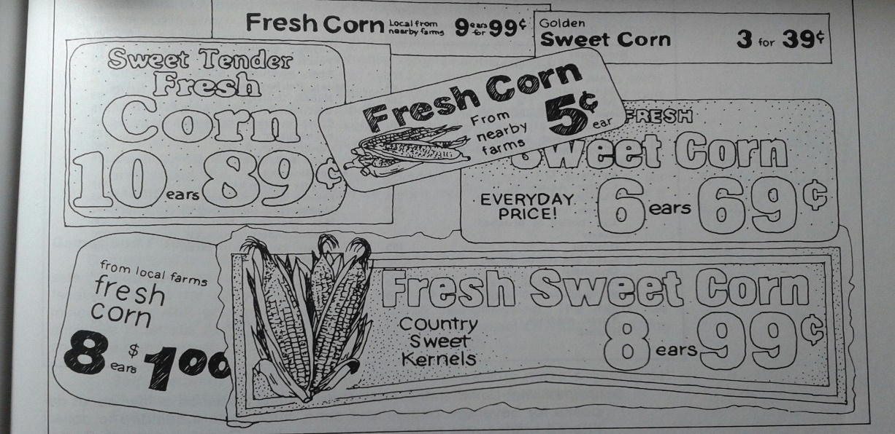

**ACTIVITY**

**Ears of Corn**

In groups, you are going shopping for corn

and searching for the best deal. Today prices

for sweet corn have changed…ALOT

**Fresh sweet corn**

**8 ears $2.50**

Walmart sells sweet corn 8 for $2.50

**Ears of Corn**

**3 for 89¢**

Super One sells sweet corn 6 for $2.00 or 12 for $3.49

Piggly Wiggly sells sweet corn 3 for 89¢

Corn, Corn, Corn

6 for $2.00 or 12 for $3.49

1. What is the ratio of corn to cost for each store?
2. Which corn is the least expensive?
3. Which corn is the most expensive?
4. Corn used to be 3 for 39¢. You want 6 sweet corn from Piggly Wiggly. What is the cost difference between then and now? Write your answer in a ratio.

Farmer Todd brought his corn to the Farmer’s Market. He is selling his sweet corn for 25¢ each or 5 for $1.00.

Would you buy corn from Farmer Todd or Super One?

If you need 30 ears of corn for the family picnic, what would it cost buying from Farmer Todd?

What would be the cost buying from Super One?

Put the price difference in ratio form.

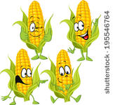

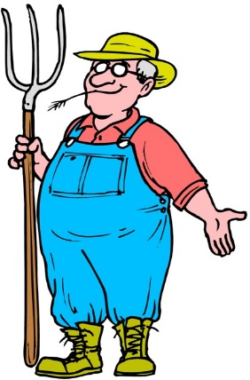

[This Photo](https://emsutopia.wikispaces.com/1+robert's+animal+farm) by Unknown Author is licensed under [CC BY-SA](https://creativecommons.org/licenses/by-sa/3.0/)

**References**

CEMC, University Of Waterloo. *MathFROG - MultipliACTION - Grade 5*. N.p., n.d. Web. 15 July 2017. <http://cemc2.math.uwaterloo.ca/mathfrog/english/kidz/mult5.shtml>.

*Code.org*. N.p., n.d. Web. 14 July 2017. <https://code.org/curriculum/course1/6/Activity6-RealLifeAlgorithms.pdf+seeds>.

*Code.org*. N.p., n.d. Web. 15 July 2017. <https://code.org/curriculum/course2/2/Teacher airplanes>.

"Fraction Circles / FREE Printable Worksheets – Worksheetfun." *FREE Printable Worksheets Worksheetfun*. N.p., n.d. Web. 16 July 2017. <http://www.worksheetfun.com/category/math-worksheetfunmenu/fraction/fraction-circles/>.

Fuys, David J. *Teaching Mathematics in the Elementary School*. Boston: Little, Brown, 1979.

Pierce, Rod. "Multiplying Mixed Numbers" Math Is Fun. Ed. Rod Pierce. 8 Dec 2016. 16 Jul 2017 http://www.mathsisfun.com/mixed-fractions-multiply.html.

"Practicing Fifth Grade Math: 'Compare Fractions and Mixed Numbers'." *IXL Learning*. N.p., n.d. Web. 16 July 2017. <https://www.ixl.com/math/grade-5/compare-fractions-and-mixed-numbers>.

*Ratio Worksheets*. N.p., n.d. Web. 16 July 2017. <http://www.commoncoresheets.com/Math/Ratios/Finding%20Ratios%20-%20Numbers/English/1.pdf>.

*The Standard Multiplication Algorithm*. N.p., n.d. Web. 15 July 2017. <http://www.homeschoolmath.net/teaching/md/multiplication\_algorithm.php>.